Transitioning Model UN conferences to online

Notes from 8-3-20 conversation

Brian Dille, I am on the board of directors for the MUNFW conference. We are beginning to plan a transition to online as plan A, live as plan B. Like most conferences, we are just starting the process to figure that out.

Differences between live and online conferences that need to be considered

- Location
  - Live – find physical space
  - Online – find tech tool (Zoom, Webex, Google Meet, Discord – most have both meeting and team variants). We need to discuss their pros and cons.

- Attendance/Participation
  - Live – schools register, travel, assigned country teams
  - Online – no travel costs, far fewer conference overhead costs, could decrease delegate costs, increase range of attendees, allow individual entry (NGOs, non-state actors)

- Plenary and Expert Speakers
  - Live – book speaker, travel cost, full day of the speaker’s schedule
  - Online – Virtual, only need speaker’s commitment for the duration of plenary – lowers cost to both conf and speaker, could increase availability & number of speakers, allows for meaningful Q&A after comments

- Committee Work
  - Live – in one room together, chair controls interaction, delegates use rules of procedure to speak and debate
  - Online – Each needs a dedicated virtual room, chair still controls interaction (even more important to have the emotional maturity to manage a room), need to rethink rules of procedure – motions that facilitate live interaction may bog down virtual

- Caucus – Heart of MUN experience for students
  - Live – mod and unmod forms – blocs physically separate to work (halls, tables, floors)
  - Online – need multiple virtual rooms for blocs to meet, online setting necessitates 1 speaker at a time, does this mean all caucuses are moderated now? Should the rooms at least be supervised by chairs?

- Resolutions
  - Little difference because almost all conferences have gone to digital doc management, at least one thing don’t have to rethink too much!

Report on Spring 2020 experiments
April 2020, MCC held a regional conference, was a consolation prize after MUNFW was cancelled, around 50 delegates

College of the Canyons conducted a late spring conference. Phil Gussin
Online Conference is an opportunity – telecommuting is the future
Conference had about 100 people – used Discord
Formal session in Zoom – preregistered for committee and received the URL
Mics turned off – debate went as normal – raised hand instead of placard
Zoom allows some things that are less complicated than live processes – like voting
Logged into the committee in Discord as well – used for caucus
Everyone turned off video when not speaking to reduce bandwidth
We limited the size of the committees to 20 people, that was a mistake because only 5-6 were actively involved, harmed the flow of debate. This fall, we will expand in size.
Almost everyone stayed for the awards ceremony, showing that they were will engaged.
In caucus, we created a bunch of rooms in discord, they could talk to each other freely. You can see who is in which room, know when a country comes into the room

Conversation notes
Q- were people not engaged when not on mike?
A – sometimes, they do have home distractions

Q – how long were the sessions?
A- did a one day session, 6 hours with a break. In the fall, will do a 2 day session
- From student perspective, 3 hours was too short. We did a 5 hour crisis committee in June, students were willing to go longer. 2, 5 hour sessions over 2 days might work

Q – messaging system?
A – in zoom , used the chat system to pass notes. In voting bloc, we disabled the chat function

Q – how can moderate bloc to prevent conversation from stopping when an opponent enters the room?
A – Same thing you do in a live session, everyone handles it until they leave.

Q – Security of discord?
A – didn’t have problem. Had the delegates preregister in zoom to prevent bombing – included contact info if there was tech problems

Chunking with accountability check to ensure engagement – what might that look like in a teleconference? – lets figure out ways to scaffold that

What about a faculty room? - great idea!

Q - Opening and closing ceremonies?
A - MCC had a good experience, plenary speaker from out of state with engaged Q&A
Canyons had a closing ceremony with SG speech and winner announcements with Powerpoint – mailed gavels to best delegates and certificates to others – it went well

Q - With schools opening – how is everyone working with high school districts not doing extracurricular?
A- push back and try to get the district to exempt academic programs from the ban since MUN will be done online – Good luck!

When reaching out to clubs, contact the student club president, who is often more involved than the advisor

Discord has a premium service, $10, only the admin needs it, opens some functions unavailable to free service

Q - Did you have tech support onboard throughout the conference? Or did your students handle that?
A- another good question for us all to think about, lets return to this

Q - Anything relevant about dress codes? Appropriate backgrounds?
A- At MCC we had a dress code, which was abided by. We used Webex, so there were no backgrounds. It seems a good idea to have a decorum requirement if using Zoom. Perhaps a standard conference background shared with credential info?

I had been looking into https://gather.town/conferences/ potentially for caucusing. Would be interested in what others think.

Q - Did you prohibit sharing cell phones numbers/other venues between delegates?
A- Not at MCC. Students do this at a live conf, so we didn’t see the need for a restriction online.

COC had a break during our longer debate (4 hours) but it seemed to break up the flow of debate and the students said they would have preferred a shorter break

Q – How did you tracking speakers?
A - Several answered excel file. Vera said ‘we used a website called MUN Coordinated. it tracks everything from speaking times to committee votes’

Q - Fall conference dates? (Both Brian and Phil invited advisors to lurk and learn)
A - COCMUN: October 24th and 25th
Arizona regional: Nov 20 and 21
SRMUN-Atlanta Oct. 23-Oct 25. You can visit srmun.org/atlanta for info.

Q - At COC, Did chairs use virtual gavels? How did you limit the speaking times for speeches?
A - We had a chair and co-chair. The co-chair's screen included the speaker's list on one side and a timer on the other.

Let's book for an hour next time!

Q - We are organizing a conference that usually sees a very high amount of delegates, and dozens of committees. We are dead worried as to how we can translate that to online.. in terms of moderating all committees and such as an organizing board. So how do you suggest we can translate that to a perfect combination of multiple platforms?
A – Ali, we're worried about the same thing! We will talk about all of these in detail in our follow up meetings

Next meeting to focus entirely on pros and cons of the various tools available, how to use them. Phil is modeling good behavior, has great instructional videos
https://www.canyons.edu/cocmun
phil.gussin@canyons.edu

The meeting moderator was Dr. Brian Dille, author of Engaging the United Nations, 2e.

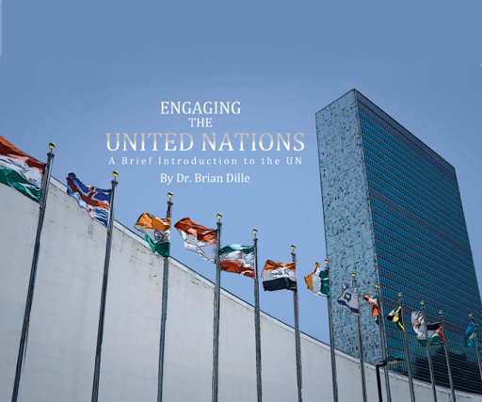

Exam Copy – www.engagingtheun.com

Sample Instructor’s guide with online exercises
email engagementlearning@gmail.com

