Online Conferences III

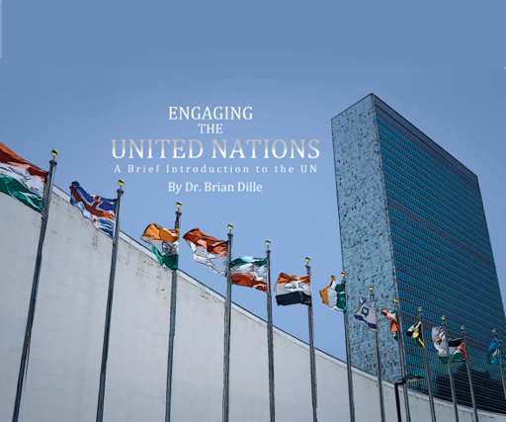

Exam Copy – www.engagingtheun.com

Sample Instructor’s guide with online exercises
email engagementlearning@gmail.com

Today we will talk about recruiting opportunities and strategies to keep students engaged in conference

Upcoming Fall Conferences

Florida MUN Oct 17
Contact Doug Ryan FMUN.org

SRMUN Atlanta Oct. 23-Oct 25.
You can visit srmun.org/atlanta for info.

COCMUN October 24th and 25th
Contact Phil Gussin phil.gussin@canyons.edu

NMUN-DC Nov 6-8,
info is at NMUN.ORG

MCCMUN Sonoran Desert Conference Nov 20 and 21
Contact Brian Dille bdille@mesacc.edu

Recruiting

Prior – Constrained by delegate cost – Travel, hotel, food
Constrained by venue limits (conf rooms, hotel blocks)
Many programs attended one or two regional conferences, maybe 1 national

Online – Travel costs erased, greatly reduced registration fee
Delegates can attend multiple conferences around country

Opportunity – Recruit nationally, flexibility in number of attendees (no room block, can rapidly wind committees up or down)

How to contact? Email invites. Contact former schools (resolve concerns over why left – finance, amenities, couldn’t do more than one national)

What approach has worked for you as an advisor?

LisaMari Centeno from Adams State in CO suggested making sure the conference is listed on Best Delegate and UNAUSA. She also said that the committee topics is a key factor in deciding what conferences to attend.

Kimberly Pace from Univ. of Alaska at Anchorage in AK said she will be reaching out to schools who used to participate, but it proved cost prohibitive since travel cost in AK is very high. Perhaps this is a time to reconsider and return. Her pitch is cost savings. She is also planning on making a lot of phone calls for recruiting, along with her Secretariat.
Charity Butcher from Kennesaw State University in GA said that when deciding what conference to attend, the time of conference was important. (not too close to finals, and also not conflicting with other major conferences)
Jack Parson from College of Charleston in SC agreed, arguing that time zones matter. The International Model African Union in February will have two or three delegations in Nairobi, Kenya, 8 hours ahead so our committees will run from 8 am to 2 pm EDT and so 4 p.m to 10 p.m. EAT

Engaging the Delegates before and during conference

Prior – in person interaction, competent chairs, quality of space, time for socializing

Online – Goes back to consistent theme – mediated experience, so interaction is different

Opportunity – reduced cost and inconvenience to speakers means can have multiple professional interactions

MUNFW Innovation – Conference held in April, but is planning expert speaker/delegate opportunities for interaction in fall and spring prior to conference, also offering training workshops. Conference becomes an academic program, not a single event. Also planning expert attendance at each committee during conference – like a hearing or actual UN conference on a topic.

Structure sequence of speakers and caucus to provide variability. More chair control over flow of debate

Engage alumni network, could host career Q&A with students.

What other things are made possible because of the reduced barriers to participation?

Katie Behnke from University of Alaska said her alumni love to jump into the conference and help cover "holes" in committees, but also have played "characters" to stir the pot and get a little action in a committee. Everybody loves it!

Pace said she has a lot of community members that join in, judges, attorneys, etc. She also said that with an online conference, close captioning will be a huge advantage for participants to catch what is being said

We talked about tools to use for caucusing, comparing Gatherly to yoTribe. Lindsey Ehinger from Jackson High School in WY helpfully shared a review with a direct comparison : https://www.conferencesthatwork.com/index.php/event-design/2020/06/gatherly-versus-yotribe-review/

Overall theme: We have to replace the lost benefits of personal interaction. For both recruiting and the student experience at conference, we can highlight the value-added opportunities that online interaction offers, things not possible or feasible at in-person conference. Make an effort to include these things, not just hold a regular conference on Zoom.

Upcoming Topics

Sept 15 11 am EDT
Running a plenary and committees caucus

Sept 29 11 am EDT
Rule changes to facilitate the online experience

Oct 13 11 am EDT
Chair training and conference management

Nov 10 11 am EDT
Commiseration

Dec 1 11 am EDT
Commiseration

