Online Delegate Training V

Welcome! The meeting will begin shortly

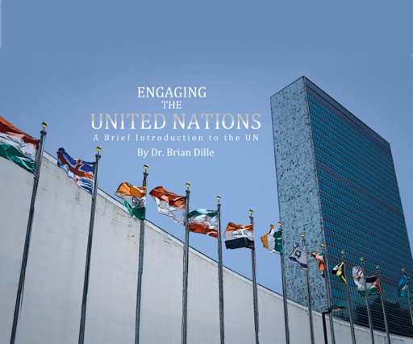

Exam Copy – www.engagingtheun.com

Sample Instructor’s guide with online exercises
email engagementlearning@gmail.com

Upcoming Fall Conferences

Florida MUN Oct 17
Contact Doug Ryan FMUN.org

SRMUN Atlanta Oct. 23-Oct 25.
Visit srmun.org/atlanta for info.

COCMUN October 24th and 25th
www.canyons.edu/cocmun
Contact Phil Gussin phil.gussin@canyons.edu

NMUN-DC Nov 6-8
Info at NMUN.ORG

MCCMUN Sonoran Desert Conference Nov 20 and 21
https://www.mesacc.edu/departments/social-science/model-un/sonoran-desert-conference
Contact Brian Dille bdille@mesacc.edu

Team Building Ideas - How can we build trust and commitment “at a distance”?
Online interaction means there is less peer pressure to do what you said you would do, you can fail in private and hope nobody notices. Delegates may be more willing to let the team down by failing. We need to think about how to create belonging and commitment in our students in new ways.
Increase the number of interactions (student-student, not instructor-student)
- International Cinema
- Question of the day
- Pair and Share
- Jigsaw
Create trust-building opportunities (also known as failure opportunities) with peer-impacting commitments
- Low-stakes
- Early and often
- Small group return and report (Chap 1 Activity 10) - p8

Phil Gussin – I am also worried about how to create that sense of connection – friendship is one of the more important aspects of Model UN. We are a community college – a class and a club. The club tends to be more playful, a way to explore the ideas they are learning in class. One thing he has done is use an online noun generator. The delegates run the generator, then have to speak for a few minutes where they have to connect the nouns (3 or 4). People laughing together is how you grow close.

Veterans take the lead in training, this teaches them leadership. This also makes new delegates more comfortable to fail. In our simulations, chairs are learning, and failing. I have borrowed Dille’s motto of “Fail Spectacularly.” It really helps the new delegates to see its OK to fail and learn. After simulations, we talk and debrief on what they learned and felt. In class, it is flipped model. Phil’s lectures are on-line, so when we are together, it is interaction, no sitting and listening to him talk.

Anyone who wants to attend his October conference as observers is welcome, just contact him. phil.gussin@canyons.edu

Aart Holtslag – His program is a class/club combo as well, they have to take the class at least once. They do a lot of social stuff through the club and have intensified the social aspect. He still keeps the three hour once a week Zoom meeting, but the returning students teach the class. As an advisor, he just keeps the agenda, gives assignments ahead of time, and creates breakout rooms, which are constantly changing. Some days they don’t notice I am there, which is a good sign.

I have them work together on the position papers, do that in real time in zoom in breakout groups. No punishment for writing less, the point is to write together and be willing to accept the criticism of others. The papers are then group projects, which creates a lot of bonding, the team knows what they are doing and why they are doing it.

Kimberly Pace – our class doesn’t meet until January, in the fall we put the secretariat together, 14 people, and we focus on training them in using zoom and setting things up. It’s a good idea to get the club up and running earlier, will start in October this year to allow time for the team-building. Will “go in” to other classrooms to recruit more folks. We typically have 40-50 people take the class, but have no idea what will happen this year.

Alison McCartney – same situation, our MUN is in the spring, so we are learning for everyone in the fall. They are starting a collegiate club. Because their conference is focused on HS students, they have different constraints, tons of rules. College students serve as coaches to HS programs. They do a training day Nov 20 as part of a college readiness program where HS students come to campus, this year will be online. Appeal to their nerdiness.

Fundraising

Institutional Funding – Student Life – MUN as one of the few co-curricular activities still operating. Pitch MUN to administrators as an academic competition that boosts the prestige of your institution. It appeals to engaged, smart students who are getting scholarship offers from other places. A solid MUN program is a reason to choose your school.

Hold a HS Conference – Charge a delegate fee slightly more than the cost. Be careful NOT to have a “fundraising conference.” The primary purpose should be to train your collegiate team or provide a service to community. Focus on quality and service - fundraising is a happy side effect, not the main purpose.

Alison – looked for donors to cover costs with budget being cut. Many of her students come from low-income families, so they still have to print materials for them. Alums are putting together a fundraising campaign ($25 to sponsor a student, $50 to sponsor a country team which you can pick) – If successful, these donations will show the university that it is worth funding.

Also, push the *global* learning for a 21st century world angle. If you have a Civic Engagment or Community Engagement Center on campus, connect MUN as citizenship? (this is another pool of money)
Allison’s program uses MUN as a tool to administer their Early College program – (this is another pool of money to tap into).

Katie Behnke – Univ of Alaska facing huge budget cuts initiated by the governor. They are cutting whole academic programs. Our university has been in a downward spiral for over 5 years.

Aart – They run things as a club, so they can access student govt money. He also pitched his program to local civics clubs (lions, elks, rotatory, UNA association) for grants and donations. This has been successful.

Lindsey - Fundraising is a nightmare for us. We don't have a college backing us up. We rely on community donations since we are a nonprofit that organizes our regional high schools conference (InterConnections 21). Our attending schools always struggle to afford our conference. I'm constantly looking for new fundraising and grant opportunities.

Upcoming Topics

Oct 5 noon EDT
Commiseration

Nov. 9 noon EDT
Open forum?

