Online Delegate Training III

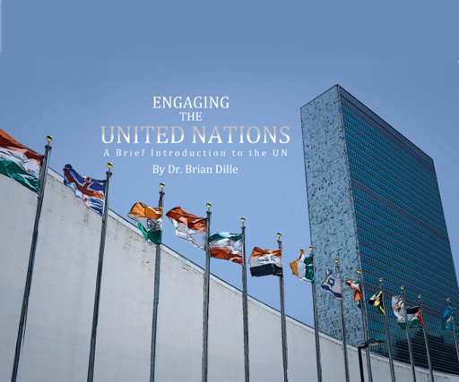

Exam Copy – www.engagingtheun.com

Sample Instructor’s guide with online exercises
email engagementlearning@gmail.com

Upcoming Fall Conferences

Florida MUN Oct 17
Contact Doug Ryan FMUN.org

SRMUN Atlanta Oct. 23-Oct 25.
You can visit srmun.org/atlanta for info.

COCMUN October 24th and 25th
Contact Phil Gussin phil.gussin@canyons.edu

NMUN-DC ,Nov 6-8, info is at NMUN.ORG
Contact Richard

MCCMUN Sonoran Desert Conference Nov 20 and 21
Contact Brian Dille bdille@mesacc.edu

Today we will share online instructional design best practices. We will use the QM rubric as a framework.

Students need to trust the training regimen. Under normal conditions, it is hard enough to convince students to do the hard work of MUN prep. They are socialized into it by the veterans. That socialization is hard to do in a mediated format like a Zoom session. It is more important than ever to set up a learning environment where students are intrinsically motivated, where they understand not only what they need to do, but WHY they need to do it. To help students be successful, you can engage in intentional design – as opposed to habitual (doing things that have worked for years) or hereditary (doing things your predecessor or mentor did).

Quality Matters is a collection of best practices for online education. These standards can guide our efforts to provide a structured learning environment for delegate training.

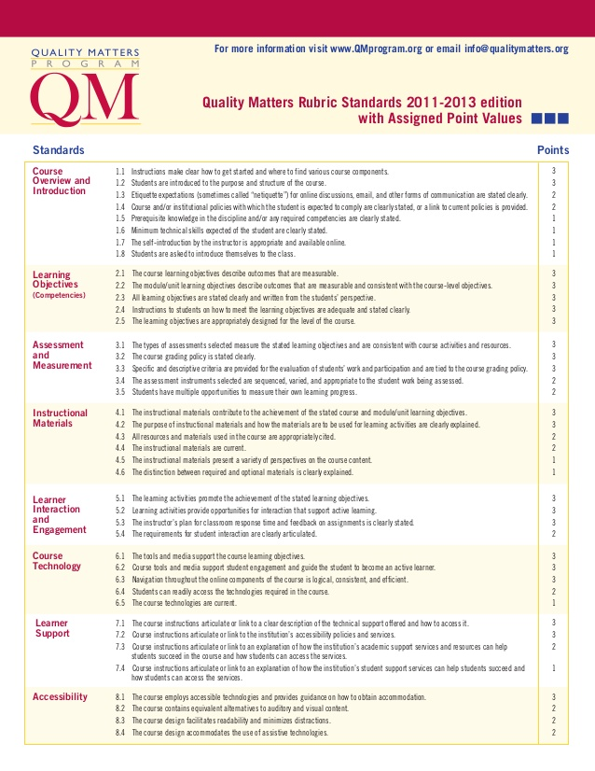

1. Instructions and expectations are clear

Surprises are rarely welcome in an on-line setting. Consider creating or linking training videos so students are not limited to simply reading the material. Let them know what the training regimen is so they can plan their lives accordingly.

2. Learning objectives are communicated and measurable

Students need to know what skills and content they are expected to master. This enables them to track their own progress and also helps set clear expectations.

3. Learning is assessed and measured, with multiple measures taken

With online instruction, it helps to have multiple, low-cost check-ins and scaffolding. Having few, large-stake, capstone like assignments does not work well because it is easier to ignore things online. Multiple check-ins provide opportunities to provide corrective feedback early when it is more useful, and encourages a sustained attention span.

4. Instructional Materials are current, and their purpose is clear to the student

The UN is shifting its practices in response to the new COVID world we live in. It will quickly become unworkable to use the same training materials you may have relied on for years. My kids did 1 semester of collegiate MUN. They were handed a pile of photocopies that were over 10 years old, then given a multiple choice test several weeks later. That was the extent of their prep materials.

Shameless self-promotion – Engaging the United Nations was written to provide an up to date introduction to the UN system. Revised in 2019. Because of the shift in practices and the geopolitics of US withdrawal from its traditional international role, another revision will probably need to be done in summer 2021.

5. Learning activities support learning objectives and student interaction requirements are clearly articulated.

Strike a balance between the need to have multiple, low-cost check-ins and scaffolding, with the need to avoid busywork. IF you are intentional about connecting activities to learning objectives, students will be more motivated to do them.

6. Students have access to the technology needed to achieve objectives.

Don’t make assumptions about tech, hardware, internet. They are probably OK, have to have that to survive in rest of their courses, but as an advisor, your relationship with students is probably closer than most, so if you don’t ask, who will?

Training videos will be useful again here, showing how to use online tools effectively.

7. Students have access to any needed support services.

Know the data privacy policies of the various communications tools you use
MUN reliance on peer review, may need to assign mentors as they may not form organically in video conf setting.

8. The training program or class employs accessible technologies.

During prep – use software that allows assistive technologies (MS Word track changes, Maria - blind, reader was gibberish)
During conf – Demand conference have interpreter for deaf if needed

Upcoming Topics

Sept 7 noon EDT
Dipping in a toe v. thrown in the deep end: Scaffolding and assessing learning activities

Sept 21 noon EDT
Dialogue on team building and fundraising

Oct 5 noon EDT
Commiseration

Oct 19 noon EDT
Open forum?

