Online Conferences V

The meeting will begin shortly

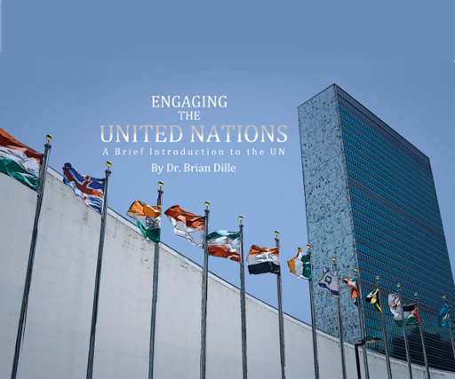

Exam Copy – www.engagingtheun.com

Sample Instructor’s guide with online exercises
email engagementlearning@gmail.com

Today we discussed rule changes that might accompany an online conference environment.

Upcoming Fall Conferences

Florida MUN Oct 17
Contact Doug Ryan FMUN.org

SRMUN Atlanta Oct. 23-Oct 25.
Visit srmun.org/atlanta for info.

COCMUN October 24th and 25th
www.canyons.edu/cocmun
Contact Phil Gussin phil.gussin@canyons.edu

NMUN-DC Nov 6-8
Info at NMUN.ORG

Teton County MUN (HS) Nov 16-17
www.tcmun.org

MCCMUN Sonoran Desert Conference Nov 20 and 21
https://www.mesacc.edu/departments/social-science/model-un/sonoran-desert-conference
Contact Brian Dille bdille@mesacc.edu
Thinking about Rules changes for an online conference

Opening Plenary - probably not much change needed as it is mainly a spectator event normally.

Committee Dynamics

Maintaining Quorum – What counts as “present” for determining vote outcomes?
LisaMari Centeno – We require cameras on at all times, and schedule breaks for bathroom or personal needs.
Jack Parson – It may make sense to require delegates have their video on during votes, otherwise they could have their video off.
Lindsey Ehinger - Gatherly use would complicate that, because cameras are off in the main committee if the delegate is in cluster. Her students attended a conference that had Gatherly going at all times, they had audio problems, and trouble sharing screens.
Katie Behnke reminded us that some may not have a reliable video stream, this is a socioeconomic issue. Delegates are coming from their houses, not all have broadband access.

Speakers list - How to set it up fairly (in person practice of not calling on the front row all the time)
Phil Gussin Use the raise hand function – chairs can try to be random – chair can uncheck the raised hand in Zoom– co-chair can track who has spoken to ensure fairness.
Michael Oleaga - I agree with Phil. If there are multiple "Raised Hands" when we're adding into the Speaker's List, our SRMUN staffers will pick randomly. Sometimes a delegates' internet connection might be a bit slow or lag to press "Raise Hand." On Zoom, the Host cannot raise a hand (only the delegates can), but the Host may lower someone's "Raise Hand."
Comments and Questions
Motions after a speaker
Phil - rudeness in a virtual form is different, we still don’t want people raising their hands during a speaker. Remind gently not to do that by using a private chat

The issue of Note passing. Easy and not secret in conference software
Rebecca Gibbons - Just tell them they are monitored!
Lindsey - Gatherly is working on a bot to catch chats for certain words – be careful about sexist or racist notes
Delegates can take a Screenshot to report it to co-chair (rapporteur or substantive)
Phil - Chairs should announce that cyberbullying is unacceptable at the beginning and encourage delegates to screenshot offending notes and submit to chair.
Michael - I think Zoom does allow participants to save chats. If a delegate experience some type of written harassment, they can save the chat, or screenshot it and report it to us.
Lindsey - The Gatherly conference we attended started out with a note on the screen to all participants that explicitly stated that chats were not recorded. I can't remember if it also said "monitored." I wasn't sure if it was for online security/safety concerns?

Suspension of meeting to move into caucus - Frequency and length –
Kimberly Pace - Chairs should suggest breaks after time period – 60 mins or so
Michael Oleaga - Virtual cuts everything down, everything takes less time, so SRMUN is cutting everything down, max 30 mins unmoderated, 15 moderated caucuses. – Chairs can rule things dilatory
Kim Pace - chairs will have to be on top of their game and much more in charge, “a kind and benevolent dictator”
Phil – Our conf built in a full hour break during lunch to give non-screen time
LisaMari - Our caucuses are 20 minutes with ability to extend for 10 more minutes. But we have some breaks that delegates could use like a caucus.
Unmoderated – Do chairs need to continuously monitor?
Phil – We used discord to talk, but the screen was google docs – this enabled them to collaborate while Secrtariat could pop in an out

Moving between GeneralSubstantive Voting bloc: Maintain supermajority rules?
Yes, the polling functions of the tool enable the chairs to see who is voting and who is not.

Voting Bloc Ideas
Phil - Disable chat function during voting bloc.
Roll call votes? Kim says no, only allowed in opening plenary
Phil also says no, especially when someone is being a “dick-lomat”
Michael - For SRMUN, we'll still use the traditional Roll Call Vote. It might be a bit slower since delegates have to press unmute and turn on their videos.

Upcoming Topics

Oct 13 11 am EDT
Chair training and conference management

Nov 10 11 am EDT
Commiseration

Dec 1 11 am EDT
Commiseration

